RMIT International University Vietnam

Assignment Cover Page (INDIVIDUAL)
Subject Code: | COMM2843
Subject Name: | Professional Communication Foundations
Location & Campus (SGS or HN) where you study: | SGS
Title of Assignment: | Critical Case Study
Student name: | Hoang Le Phuong Dung
Student Number: | S3957038
Teachers Name: | Justin Michael Battin
Group Number: | 01
Assignment due date: | 20th May 2023
Date of Submission: | 20th May 2023
Number of pages including this one: | 14
Word Count: | 2,136 words
Declaration of Authorship:  Make sure to read the Assessment Declaration https://www.rmit.edu.au/students/studentessentials/assessment-and-exams/assessment/assessment-declaration | I declare that in submitting all work for this assessment I have read, understood and agree to the content and expectations of the Assessment Declaration
Consent to Use (KEEP ONLY ONE SENTENCE): | I do NOT give RMIT University  permission to use my work

CASE STUDY: Hem Cut Comedy Series
HOANG LE PHUONG DUNG- S3957038
s3957038@rmit.edu.vn

INTRODUCTION
In recent years, there have been significant media publications produced by Vietnamese artists on social media along with the growth of their public's image (Da Ly 2020). Howbeit, there were adverse situations in the Vietnamese online community due to constant battles between celebrities , especially the drama calling for charity donations for the Central Region causing many artists to suffer heavy attacks and reduced reputation because of their slow disbursement of donations to the victims of the natural disaster in 2021 (Ha Trang 2021) .Although they tried to solve the problems by posting on their social media numerous explanations and apologies (Nhat Thu 2021), they could not gain the trust of public (Thien Anh 2021). As a result, at Tet 2022, Tran Thanh released the comedy series called “Hem Cut” on his YouTube channel with the content reflecting the social situation of that tumultuous time, especially emphasizing the public opinion led by livestreams on social networks that could smother the artists. This is particularly mentioned in the first 6 minutes of the 4th episode :” The Gioi Tren Moi”, in which he used a similar context as a metaphor to address one of the most controversial exaggerations in his real life: the amount of money he raised was only 8 billion but it was said to be 120 billion instead (Tien Vu 2022). After releasing, through the perspective of Laswell’s model, the series attracted attention with more than five million views, holding the top 1 trending position on YouTube for many days (Lam Tran 2022) and receiving plentiful audience’s compliments on both the scripts and natural acting of the artists (Appendix A). Since then, the purpose of this case study is to use framing theory and narrative paradigm to invite new understandings about how artists communicate with their audiences regarding controversial issues.

SIGNIFIGANCE
According to Marta G and Martin Q (2021), in Vietnam, the creative industry is experiencing significant growth, particularly in the realm of the creative economy and content creation on social networks. In that industry, artists play a crucial role in shaping culture, creating artworks, and conveying positive messages (Thao Dung 2021). For instance, Den Vau utilises his music to raise awareness and support those in need, as seen in his music video "Nau An Cho Em". He donates the revenue generated from the song's views to construct schools and provide free meals for children in remote areas (Mai Nhat 2023) . Another example is Khanh Vy, a renowned MC for VTV national television station, who serves as an inspiration for young people in their pursuit of knowledge (Nhan Ma 2020). As Siyoung C and Hichang C (2017) stated that the role of celebrities enables them to establish direct communication channels with their audience. However, some celebrities have improper behaviour on social media which contradicts the expected responsibilities they should fulfil. Consequently, it negatively affects their public image and involves disseminating a pessimistic or unfavourable message. Consequently, this phenomenon indicates that many artists in Vietnam lack effective means of communication with their audiences. One notable example is Xuan Bac, an artist who criticised his own audience (Mai Nhat 2023). Additionally, another singer named Hien Ho has faced controversy for engaging in a relationship with a married man, disrupting a family's happiness. Instead of addressing the issue, she remained silent and later reemerged in the public as if nothing had occurred (Ha Trang 2023). In summary, when artists find themselves embroiled in scandals, their responses often involve remaining silent, issuing apologies, or engaging in charitable acts (Thu An 2023)
However, Frank A (2016) stated that contemporary audiences are becoming more demanding and actively engaged, they no longer tolerate such behaviour (Thao My and Ha Anh 2022). Today's audiences have become increasingly critical of artists involved in scandals and anti-groups protesting artists' improper manners are emerging. The public employs a more civilised approach to boycott, conducts thorough research and analysis before deciding to oppose or criticise according to media expert Ngo Ba Luc (Thu An 2023). Besides that, the audience fully supports the ban on broadcasting for artists and KOLs who violate the law (Thai Thai 2023). Despite the efforts of these artists to explain their situations through posts and livestreams, the public remains unconvinced by their explanations. Consequently, the issue remains controversial. On the other hand, Tran Thanh's comedy series has garnered public support and acclaim. The way he communicates with the audience in the series is novel, conveying more civilised, compassionate, and meaningful messages. It represents a fresh approach to engaging with today's audiences.

ANALYSIS
The assessment of narrative rationality frequently revolves around two primary criteria: narrative coherence and narrative fidelity (Fisher cited in Griffin, Ledbetter, Sparks 2018). This section aims to demonstrate how Tran Thanh uses the comedy series to manage his public image in response to dramatic events by examining the combination of these two elements and comedy of manners. Within the framework of the narrative paradigm, narrative coherence pertains to consistent character behaviour and overall story cohesiveness, while narrative fidelity refers to the truthfulness and logical reasoning within the narrative (Fisher 1985). In the comedy series, Tran Thanh employs a persuasive strategy that constructs a plot based on his authentic experiences with the drama. Specifically, he chooses a setting in a typical Vietnamese alley where working-class people reside, as this lifestyle, according to Dong Dong T and Bao Thanh N (2021) explained that it is familiar to the Vietnamese population, with approximately 85% of Ho Chi Minh City residents living in such alleys.

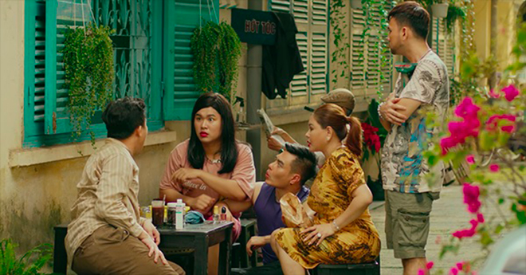Figure 1: Tran Thanh Town (2022) The familiar image in the alleys of the Sai Gon people is reproduced is reproduced in the series [photograph],Vnmedia website, accessed 15 May 2023. https://vnmedia.vn/giai-tri-so/202201/hem-cut-web-drama-tet-cua-tran-thanh-tien-thang-top-1-trending-youtube-6e05970/

Mike et al. (2014) argued that this authenticity increases consumer trust, leading to positive attitudes. As a result utilizing familiar elements, Tran Thanh facilitates the audience's comprehension and accessibility to the film's content. Additionally, the narrative unfolds naturally and logically, commencing with a regular morning in a small alley where individuals are engaged in their daily routines. The interruption caused by Tu Dao Lam's shouting action surprises everyone and mirrors the sudden actions of Nguyen Phuong Hang in real life, who loudly live streams online slander, generating an uproar within the online community (Minh Hy 2022). Tran Thanh integrates reality into the storyline while preserving its authenticity. Furthermore, the characters embody common traits found in Vietnamese society, such as the acerbic nature of Tu Dao Lam along with the tendency of YouTuber Quynh Nhu to pry into others' privacy (Tran thanh Town 2022) and another notable character is Manh, who exemplifies the pursuit of fame at the expense of speaking ill, cursing, and attacking others online (Figure 2).

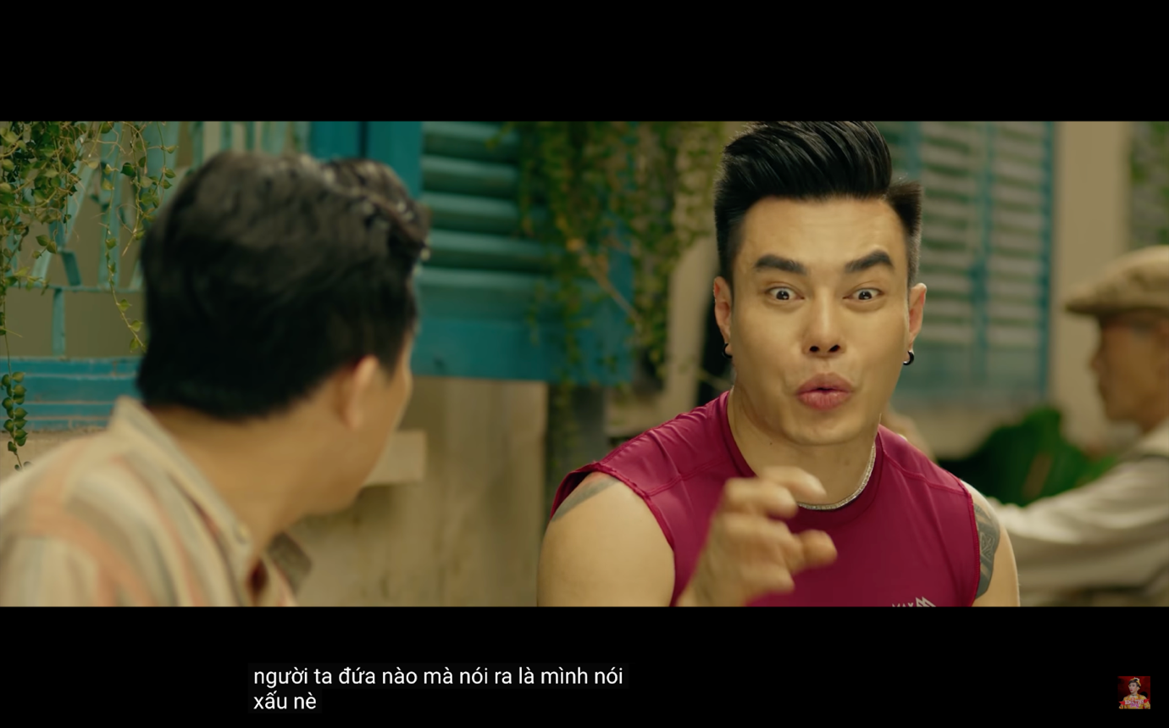
Figure 2: Tran Thanh Town (2022) Manh character advises Tran Thanh to put aside his conscience and speak ill of others in order to get more views during the livestream [video],Youtube website, sec. 2:58

This comedy style employed in the series reflects certain truths in life without overwhelming the audience, falling under the category of comedy of manners that satirizes the follies, vanities, hypocrisies, and weaknesses of individuals (Hasa 2016). The comedy of manners effectively critiques societal hypocrisies by employing subtle satire that does not overwhelm or fatigue the audience (Britannica n.d). Furthermore, Hovland et al. (1951) explained that the effectiveness of a message conveyed by an endorser relies on their ability to establish trustworthiness by convincing audiences of the presented information's veracity. Ultimately, through the natural plot, utilization of familiar elements, and a humorous approach, Tran Thanh created a new method to establish a preliminary connection that enables the audience to easily engage with the series' content.

Moving to the framing theory part, Tran Thanh first establishes a narrative paradigm as a foundation, enabling the audience to readily engage with the series. Subsequently, he strategically employs profound dialogues which are specifically focused on in the present analysis. These dialogues serve as a catalyst for transforming the audience's perception of significant issues, employing the lens of framing theory to achieve this effect. According to the framing theory, people rely on preconceived notions and stereotypes to make sense of their social environments. Daily interactions and media content observation both play a role in the development of these expectations, which are also known as stereotypes, attitudes, schemes, and racial or ethnic prejudices (Baran SJ & Davis DK 2012). Moreover, as maintained by the framing theory, the media highlights specific events, organizing information to shape public’s opinion (Stephen WL and Karen AF 2017). To be more specific, in the 4th episode, the public’s views have changed by the use of metaphor framing technique (Yan J and Lucinda A 2022), Tran Thanh delivered a series of lines that gained tremendous attention on social media. The dialogue revolved around the character Nhu Quynh, a YouTuber and a representation of a real-life businesswoman named Nguyen Phuong Hang and Sau Ngot, another character, confronted Nhu Quynh with powerful statements that shed light on a prevalent issue at the time: Mr. Sau Ngot inquired if she personally witnessed the alleged incident of money being taken. He specifically asked, "So you saw them take it with your own eyes?" However, her response was, "No. I dreamed." (Tran Thanh Town 2022).

When everything came to light, the other female YouTuber Nhu Quynh continued to take turns to become another victim of cyber violence, tasting everything from disparaging looks to her cursed family Sau Ngot's dialogue with YouTuber Nhu Quynh immediately received a lot of sympathy from viewer: Mr. Sau Ngot confronted Nhu Quynh youtuber about the potential repercussions of speaking negatively about others. He highlighted the inconsistency in her behaviour of defaming others and the importance of having substantiated evidence while doing so. He also made a clear distinction between rightful condemnation and engaging in slander or delving into someone's private life (Tran Thanh Town 2022). This dialogue directly reflected a widespread situation on social networks at that time that celebrities exploited their influence to continuously release information, unverified or inaccurate with the public, they even invade the privacy of other famous people when talking about private personal information as material for their social media statements. Thereby, Sau Ngot's dialogue not only made the audience think about the issue at hand but also influenced how they should approach it (Weaver D 2007). In the decoding of the message, in parallel with Wseas LLC (2014), effective communication requires the transmitted content to be received and understood in the intended manner, aiming to create a common perception, changing behaviors, and providing information. Tran Thanh, with the original intention of creating the comedy Tet, also with the aim of solving the scandals that he had experienced in the past year, has succeeded in getting the audience's approval with his lines themselves, they recognize him as an artist with civilised and profound behaviour. Since then, he has slowly regained the sympathy of the audience and saved his reputation (Appendix B). And above all, Tran Thanh also demonstrates the role of artists and celebrities in providing a new, creative and fresh perspective, changing mind-sets and constructing new narratives (Lummina H et al 2017). In summary, Tran Thanh effectively utilised framing theories to shape the perception of his audience. He employed straightforward and relatable metaphors in the dialogue to convey complex situation. By doing so, he subtly guided individuals towards a positive perspective and skillfully resolved the conflicts within the dramas he presented (yeah1 n.d)

CONCLUSION
In the final analysis, as mentioned above, Tran Thanh, through the "Hem Cut" comedy series, has introduced two significant insights for artists in their communication with the audience. Firstly, he emphasizes the importance of creating a natural and relatable plot by incorporating humor into real-life experiences of artists. This approach effectively engages the audience and facilitates their understanding by presenting these experiences in a smaller, familiar context through the use of straightforward metaphors and profound dialogue. Tran Thanh's approach offers a solution for artists to address the audience's desire for authenticity and depth in both the content and manner in which the artist interacts with their audiences. This understanding highlights the significance of building trustworthiness with the audience, as it plays a crucial role in influencing their attitudes and perceptions towards artists and their work. Furthermore, while this case study focuses on the application of framing theory and narrative paradigm to explore artist-audience communication regarding controversial issues, it also has the potential to serve as a resource for future research projects. Specifically, it can contribute to the analysis of audience consumption patterns and their level, elements of trust in celebrities as mentioned by Riyana P and Ratna R (2021) stated that trustworthiness is a vital factor in determining the credibility of a source. Without trustworthiness, other attributes of the celebrities may not effectively influence consumer attitudes.
.

REFERENCES

Da Ly (05 April 2020) ‘Nghe si lan toa nang luong tich cuc (Artists who spread positive energy)’, Thanh Nien, accessed 10 May 2023. https://thanhnien.vn/nghe-si-lan-toa-nang-luong-tich-cuc-185943041.htm

Ha Trang (2021) ‘Lum xum tu thien nam 2021: Loat nguoi noi tieng bi “sao ke chieu menh. (Charity controversy in 2021: A series of celebrities are "destined by the statement)’ , Tien Phong, accessed 10 May 2023. https://tienphong.vn/lum-xum-tu-thien-nam-2021-loat-nguoi-noi-tieng-bi-sao-ke-chieu-menh-post1401331.tpo

Nhat Thu (2021)’ Loat sao Viet gap rac roi voi hoat đong tu thien (Vietnamese stars have trouble with charity activities)’, Vnexpress, accessed 10 May 2023. https://vnexpress.net/loat-sao-viet-gap-rac-roi-voi-hoat-dong-tu-thien-4353076.html

Thien Anh (2021), ‘Niem tin đang bi xoi mon (Trust is being eroded)’, Thanh Nien, accessed 10 May 2023. https://thanhnien.vn/niem-tin-dang-bi-xoi-mon-1851110099.htm

Tien Vu (2022), ‘“Hem Cut” va Loi Đap Tra Cua Tran Thanh Sau Mot Nam Bi Nghi Ngo, Chi Trich (‘“Hem Cut” and Tran Thanh’s Answer After a Year of Doubt and Criticism)’, Tuoi Tre, accessed 22 April 2023. https://tuoitre.vn/hem-cut-va-loi-dap-tra-cua-tran-thanh-sau-mot-nam-bi-nghi-ngo-chi-trich-20220210151032144.htm

Lam Tran (2022) ‘“Hem Cut”, web drama Tet cua Tran Thanh tien thang Top 1 trending YouTube (“Hem Cut”, Tran Thanh's Tet web drama goes straight to Top 1 trending YouTube)’, Vnmedia, accessed 10 May 2023. https://vnmedia.vn/giai-tri-so/202201/hem-cut-web-drama-tet-cua-tran-thanh-tien-thang-top-1-trending-youtube-6e05970/

Tran Thanh Town (8 February 2022) 'Hai tet tran thanh hem cut -tap 4: the gioi tren moi ('Hem Cut's New Year comedy -episode 4: the world on lips )’' [Youtube post] , Tran Thanh Town, accessed 10 May 2023. https://www.youtube.com/watch?v=YBN6_nKStZg

Marta G and Martin Q (2021) 'The INCITE model of policy development for the creative industries: the case of Vietnam', Journal of Asian Business and Economic Studies , 28(1):31-46, doi: 10.1108/JABES-12-2019-0125

Thao Dung (2021) ‘Nghe si long ngon tren mang xa hoi: “Rac” van hoa can loai bo (Artist blasphemies on social networks: Cultural 'garbage' needs to be eliminated)'’, Cong An Nhan Dan, accessed 10 May 2023. https://cand.com.vn/Kinh-te-Van-hoa-The-Thao/Nghe-si-long-ngon-tren-mang-xa-hoi-Rac-van-hoa-can-loai-bo-i617518/

Mai Nhat (2023) ‘Ca khuc ve tre vung cao cua Den Vau gay chu y (Den Vau's song about rural area children attracts attention)', VNExpress, accessed 10 May 2023. https://vnexpress.net/ca-khuc-ve-tre-vung-cao-cua-den-vau-gay-chu-y-4605128.html

Nhan Ma (2020) ‘Khanh Vy – MC tieng Anh đuoc yeu thich tren VTV lan đau noi ve gia phong nghiem khac đe co tam bang đo Hoc vien Ngoai giao cung khoi "tai san" đang nguong mo (Khanh Vy - Favorite English MC on VTV for the first time talked about strict family rules to get a diploma of Diplomatic Academy and admirable properties.)’, afamily, accessed 10 May 2023. https://afamily.vn/khanh-vy-hot-girl-7-thu-tieng-mc-tieng-anh-duoc-yeu-thich-tren-vtv-lan-dau-noi-ve-gia-phong-nghiem-khac-de-co-tam-bang-do-hoc-vien-ngoai-giao-cung-khoi-tai-san-dang-nguong-mo-20200718152940588.chn

Siyoung C and Hichang C (2017) 'Fostering parasocial relationships with celebrities on social media: implications for celebrity endorsement', Special Issue:Technological Impacts on Market Attitudes and Behaviors, 34(4): 481–495. doi:10.1002/mar.21001

Mai Nhat (2023) ‘Xuan Bac dung ngu ngon an y đop chat khan gia la khong chap nhan duoc (It's unacceptable for Xuan Bac to use a metaphor to tease the audience)’, VNExpress, accessed 15 May 2023. https://vietnamnet.vn/xuan-bac-dung-ngu-ngon-an-y-dop-chat-khan-gia-la-khong-chap-nhan-duoc-2103966.html

Ha Trang (2023) ‘Hien Ho hon nhien tro lai nhu chua tung co scandal, nhung that bai (Hien Ho blatantly returned as if there had never been a scandal, but failed)’, Tien Phong, accessed 18th May 2023. https://tienphong.vn/hien-ho-hon-nhien-tro-lai-nhu-chua-tung-co-scandal-nhung-that-bai-post1522109.tpo

Thu An (2023) ‘Nghe si Viet vuong scandal: Toan xin loi online cho co (Vietnamese artists involved in scandals: Just post apology on social media)’, Tien Phong, accessed 18 May 2023. https://tienphong.vn/nghe-si-viet-vuong-scandal-toan-xin-loi-online-cho-co-post1528076.tpo

Frank A (2017) 'Opposing conceptions of the audience: the active and passive hemispheres of mass communication theory', Annals of the International Communication Association, 11(1): 51-80. doi: 10.1080/23808985.1988.11678679

Thao My and Ha Anh (2022) 'Nghe si Viet tro lai sau scandal: Khan gia ngay cang khat khe va can nhung ngoi sao tai đuc ven toan ('Vietnamese artists come back after scandal: The audience is stricter and needs talented stars with integrity) ', afamily, accessed 10 May 2023. https://afamily.vn/nghe-si-viet-tro-lai-sau-scandal-khan-gia-ngay-cang-khat-khe-va-can-nhung-ngoi-sao-tai-duc-ven-toan-20220828083558086.chn

Thai Thai (2023) 'Khan gia ung ho han che phat song voi nghe si, KOL vi pham phap luat (Audiences support restricting broadcasting with artists, KOL breaking the law)', Tuoi Tre, accessed 10 May 2023. https://tuoitre.vn/khan-gia-ung-ho-han-che-phat-song-voi-nghe-si-kol-vi-pham-phap-luat-20230418151937608.htm

Griffin E, Ledbetter A and Sparks, G. (2018) ISE EBook Online Access for a First Look at Communication Theory, 10, McGraw-Hill US Higher Ed ISE

Fisher W.R (1985) 'The narrative paradigm: An elaboration', Communication Monographs, 52(4): 347–367, doi: 10.1080/03637758509376117

Dong Dong T and Bao Thanh N (2021) 'Urban Space in Ho Chi Minh city alleys', Journal Of Construction, (7):1-4.

Mike S, Christoph B and Nicola R (2014) 'Brand authenticity: Model development and empirical testing', Journal of Product & Brand Management, 23(3): 192–199, doi: 10.1108/JPBM-06-2013-0339

Minh Hy (2022) ‘Loat nghe si tung bi ba Nguyen Phuong Hang chui tren song livestream (A series of artists who were cursed by Ms. Nguyen Phuong Hang on the livestream)’, Thanh Nien, accessed 15 May 2023. https://thanhnien.vn/loat-nghe-si-tung-bi-ba-nguyen-phuong-hang-chui-tren-song-livestream-1851441969.htm

Hasa (2016) What is Comedy of Manners | Themes, Characteristics, Examples, Pediaa website, accessed 15 May 2023. https://pediaa.com/what-is-comedy-of-manners/

Britannica (n.d) 'comedy of manners', in Luebering JE (ed/es), comedy of manners
narrative genre.

Carl H and Walter W (1951) 'The influence of source credibility on communication effectiveness', Public Opinion Quarterly, 15(4): 635-650, doi: 10.1086/266350

Baran S J and Davis D K (2014) Mass communication theory: Foundation,
ferment, and future, 7, Cengage Learning, Boston

Stephen WL and Karen AF (2017) Theories of Human Communication, 10 , Thomson Wadsw, USA

Yan J and Lucinda A (2022), Social Media and Crisis Communication, 2, Routledge, New York

Tran Thanh Town (27 February 2022) 'HẺM CỤT - Hậu Trường Tập 4 | Trấn Thành, Lê Giang, Dương Lâm, Quốc Khánh, Lộ Lộ, AQuay, Hoàng Mèo' [format] , TRAN THANH TOWN, accessed 10 May 2023. https://www.youtube.com/watch?v=uGR_qBlJqfs

Tran Thanh Town (8 February 2022) 'Hai Tet Tren Thanh HEM CUT -Tap 4 | THE GIOI TREN MOI |Le Giang, Duong Lam, Quoc Khanh, Lo Lo, AQuay' [video], TRAN THANH TOWN, Youtube website, accessed 18 May 2023. https://www.youtube.com/watch?v=YBN6_nKStZg

Weaver D (2007) 'Thoughts on Agenda Setting, Framing, and Priming', Journal of Communication, 57(1):142 - 147, doi:10.1111/j.1460-2466.2006.00333.x

Wseas LLC (19 December 2014) 'Recent Advances in Financial Planning and Product Development: Icfa '14, Icdpd '14' [conference presentation], Proceedings of the 5th International Conference on Finance, Accounting and Law (ICFA '14)Proceedings of the 5th International Conference on Design and Product Development (ICDPD '14), North Atlantic University Union, accessed 19 May 2023. https://books.google.com.vn/books/about/Recent_Advances_in_Financial_Planning_an.html?id=uMUMswEACAAJ&redir_esc=y

Lummina H (2017) 'THE ROLE OF ARTISTS AND RESEARCHERS IN SUSTAINABLE PLACE-SHAPING', in Sari A, Claudia B, Katarzyna P, Ljiljana R and Katriina S (ed/s) Culture In Sustainablity: Towards a Transdisciplinary Approach, Jyväskylän yliopisto, SoPhi
Yeah1 (n.d), NSND Viet Anh cam nhan ve web drama Hem Cụt cua Tran Thanh: San pham hai khong san si, cai xau nup duoi cai dep (People's Artist Viet Anh feels about Tran Thanh's web drama Dead End Alley: A comedy product that doesn't have a grudge, the ugly hiding under the beauty), Yeah1 website, viewed 23 April 2023, <https://yeah1.com/phim-online/nsnd-viet-anh-cam-nhan-ve-web-drama-hem-cut-cua-tran-thanh-cai-xau-nup-duoi-cai-dep-OzVwW2RZVB.html>.
Riyana P and Ratna R (2021) ‘The role of celebrity endorser toward brand attitude and purchase intention: A study from Indonesia’, International Journal Of Research In Business And Social Science ,10(8): 68-75.

Appendix
Appendix A:
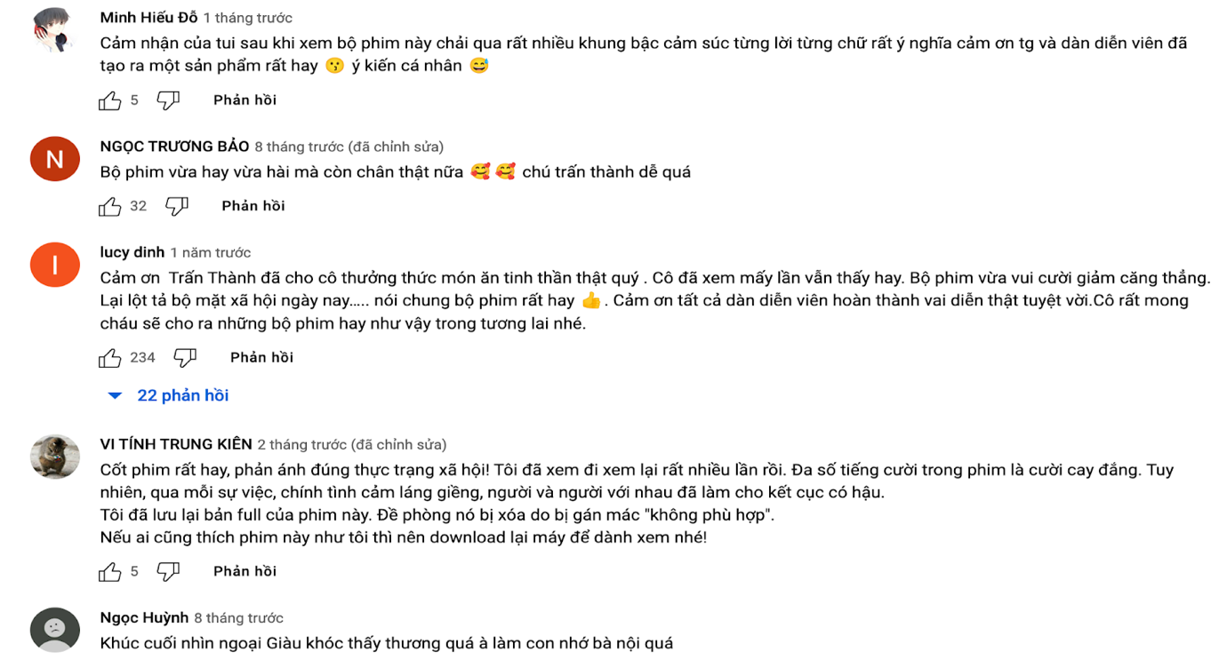
Source: TRAN THANH TOWN 2022
Appendix B:
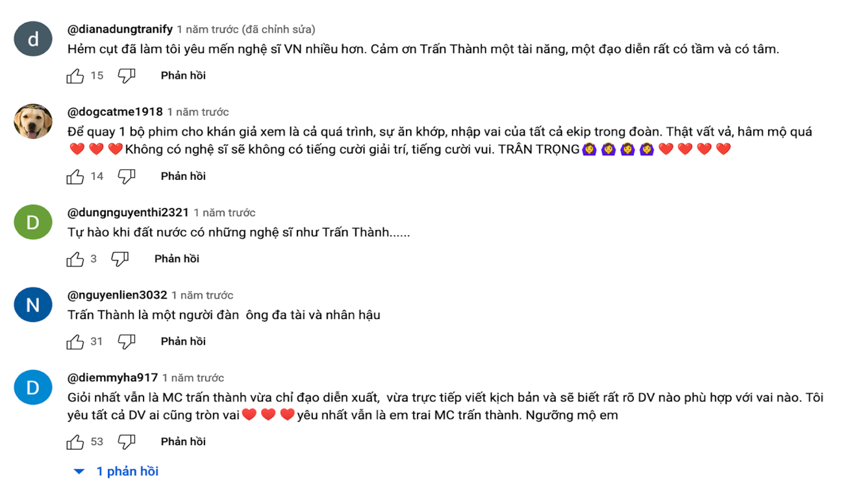
Source: TRAN THANH TOWN 2022

